Universidade do Algarve
  - Faculdade de Ciências e Tecnologia
  - Licenciatura em Engenharia Informática

Redes de Computadores I

Laboratório 4
Wireshark – DNS Query em Python

Realizado por: Diogo Carvalho nº 90247
PL: 2
Docente: Rui Filipe Rosa Paulo
Ano Letivo: 2025/2026

Relatório

Codigo

DNS_query.py
import socket
import struct
import random

dnsserver = "10.10.22.228"
portnumber = 53

# transforma o domínio no formato usado pelo DNS
# exemplo: ualg.pt -> 04 ualg 02 pt 00
def encode_name(domain):
parts = domain.split(".")
name = b""

for part in parts:
name += struct.pack("!B", len(part))
name += part.encode()

name += b"\x00"
return name

# cria a mensagem da query
def build_query(domain):
transaction_id = random.randint(0, 65535)

# standard query + recursion desired
flags = 0x0100

# 1 pergunta, resto a 0
qdcount = 1
ancount = 0
nscount = 0
arcount = 0

# header DNS tem sempre 12 bytes
header = struct.pack(
"!HHHHHH",
transaction_id,
flags,
qdcount,
ancount,
nscount,
arcount
)

# question section
qname = encode_name(domain)
qtype = 1 # A
qclass = 1 # IN

question = qname + struct.pack("!HH", qtype, qclass)

return transaction_id, header + question

# lê nomes dentro da mensagem DNS
def read_name(message, offset):
labels = []

while True:
length = message[offset]

# se começar por 11, é um pointer
if (length & 0xC0) == 0xC0:
pointer = struct.unpack("!H", message[offset:offset + 2])[0]
pointer = pointer & 0x3FFF
name, _ = read_name(message, pointer)
labels.append(name)
offset += 2
break

# 0 quer dizer fim do nome
if length == 0:
offset += 1
break

offset += 1
labels.append(message[offset:offset + length].decode())
offset += length

return ".".join(labels), offset

# lê um resource record
def read_record(message, offset):
name, offset = read_name(message, offset)

rtype, rclass, ttl, rdlength = struct.unpack("!HHIH", message[offset:offset + 10])
offset += 10

rdata_start = offset
rdata = message[offset:offset + rdlength]
offset += rdlength

return {
"name": name,
"type": rtype,
"class": rclass,
"ttl": ttl,
"rdlength": rdlength,
"rdata": rdata,
"rdata_start": rdata_start
}, offset

# imprime um resource record
def print_record(record, message, number):
print("\nRegisto", number)
print("Nome:", record["name"])
print("Tipo:", record["type"])
print("Classe:", record["class"])
print("TTL:", record["ttl"])

# A -> endereço IPv4
if record["type"] == 1 and record["rdlength"] == 4:
ip = socket.inet_ntoa(record["rdata"])
print("IP:", ip)

# NS -> nome do servidor
elif record["type"] == 2:
ns_name, _ = read_name(message, record["rdata_start"])
print("NS:", ns_name)

# CNAME -> nome canónico
elif record["type"] == 5:
cname, _ = read_name(message, record["rdata_start"])
print("CNAME:", cname)

# MX -> preferência + servidor de mail
elif record["type"] == 15:
preference = struct.unpack("!H", record["rdata"][:2])[0]
mx_name, _ = read_name(message, record["rdata_start"] + 2)
print("Preference:", preference)
print("MX:", mx_name)

# outros tipos ficam em hexadecimal
else:
print("RDATA:", record["rdata"].hex())

def main():
domain = input("Domínio: ")

query_id, query = build_query(domain)

# socket UDP
client = socket.socket(socket.AF_INET, socket.SOCK_DGRAM)
client.settimeout(5)

# envia a query
client.sendto(query, (dnsserver, portnumber))

# recebe a resposta
response, address = client.recvfrom(4096)

print("\nResposta de:", address)

# header
header = struct.unpack("!HHHHHH", response[:12])

response_id = header[0]
flags = header[1]
qdcount = header[2]
ancount = header[3]
nscount = header[4]
arcount = header[5]

print("\n--- HEADER ---")
print("ID:", hex(response_id))
print("Flags:", hex(flags))
print("Questions:", qdcount)
print("Answer RRs:", ancount)
print("Authority RRs:", nscount)
print("Additional RRs:", arcount)

offset = 12

# question section
print("\n--- QUESTION SECTION ---")
for _ in range(qdcount):
qname, offset = read_name(response, offset)
qtype, qclass = struct.unpack("!HH", response[offset:offset + 4])
offset += 4

print("Nome:", qname)
print("Tipo:", qtype)
print("Classe:", qclass)

# answer section
print("\n--- ANSWER SECTION ---")
for i in range(ancount):
record, offset = read_record(response, offset)
print_record(record, response, i + 1)

# authority section
print("\n--- AUTHORITY SECTION ---")
for i in range(nscount):
record, offset = read_record(response, offset)
print_record(record, response, i + 1)

# additional section
print("\n--- ADDITIONAL SECTION ---")
for i in range(arcount):
record, offset = read_record(response, offset)
print_record(record, response, i + 1)

client.close()

if __name__ == "__main__":
main()

Resultados

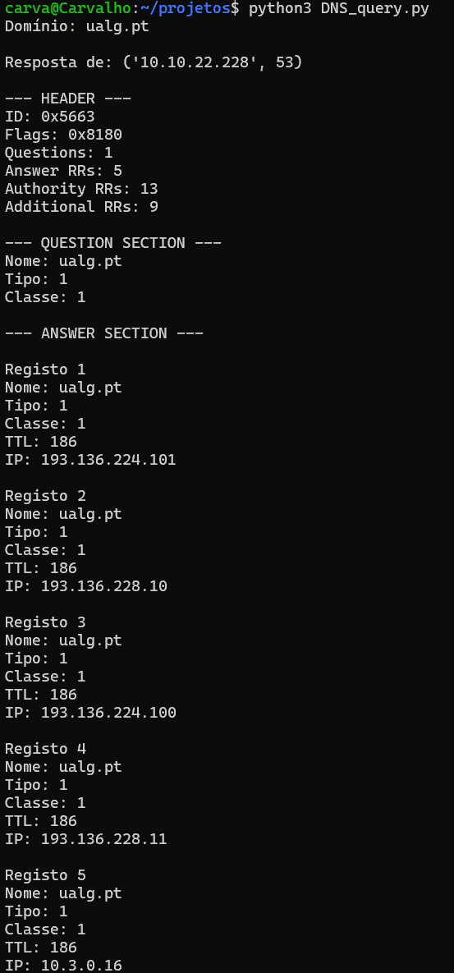
Execuçao do programa
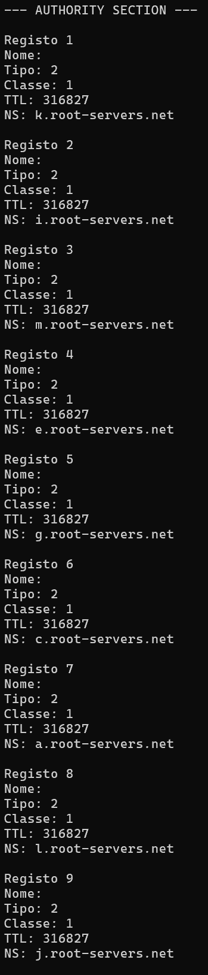
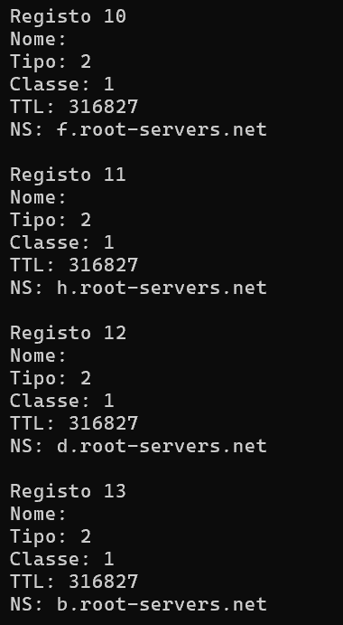
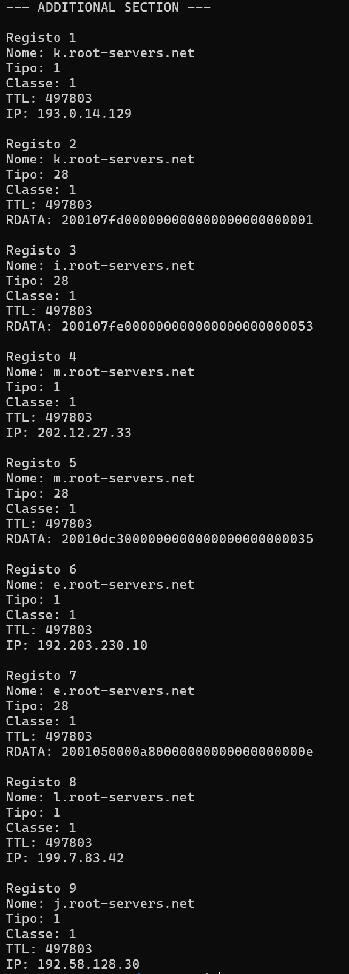
Mensagem enviada
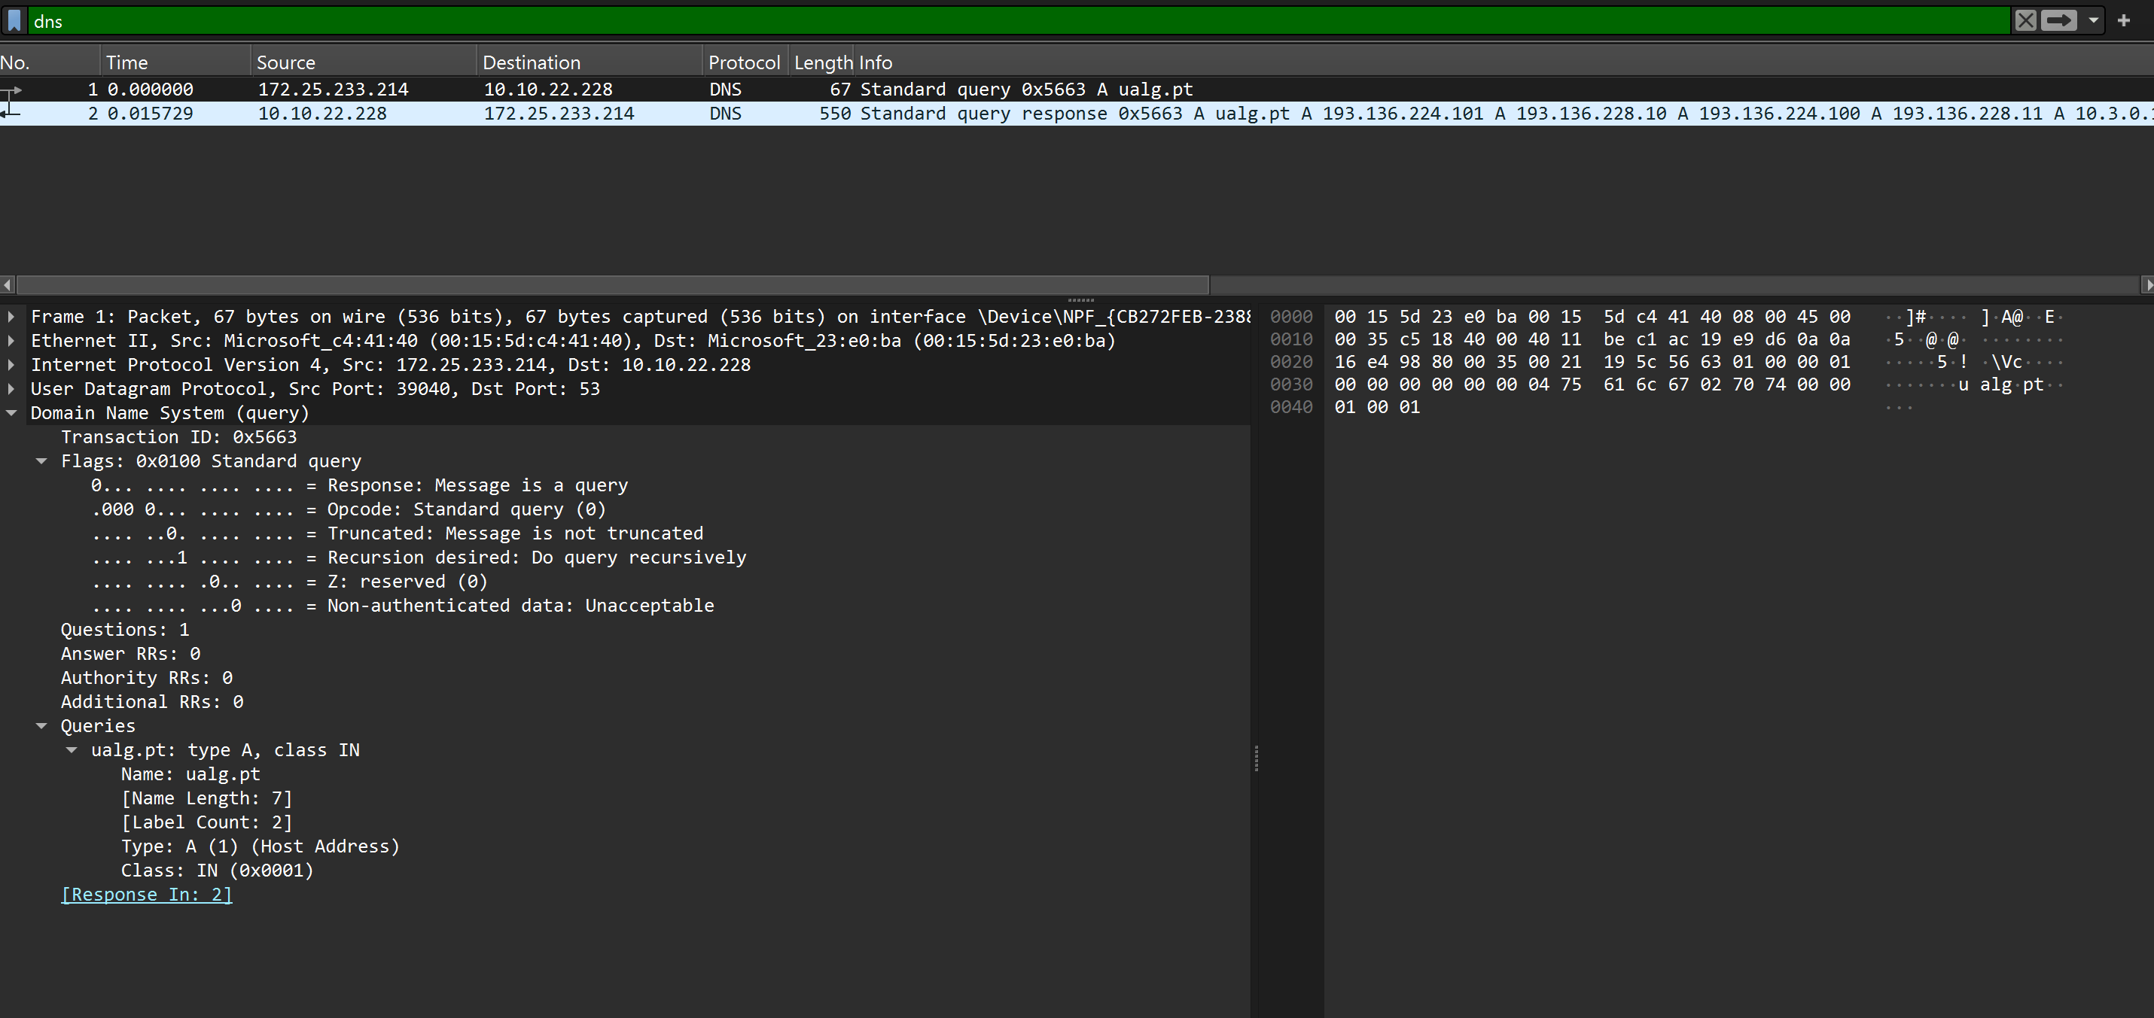

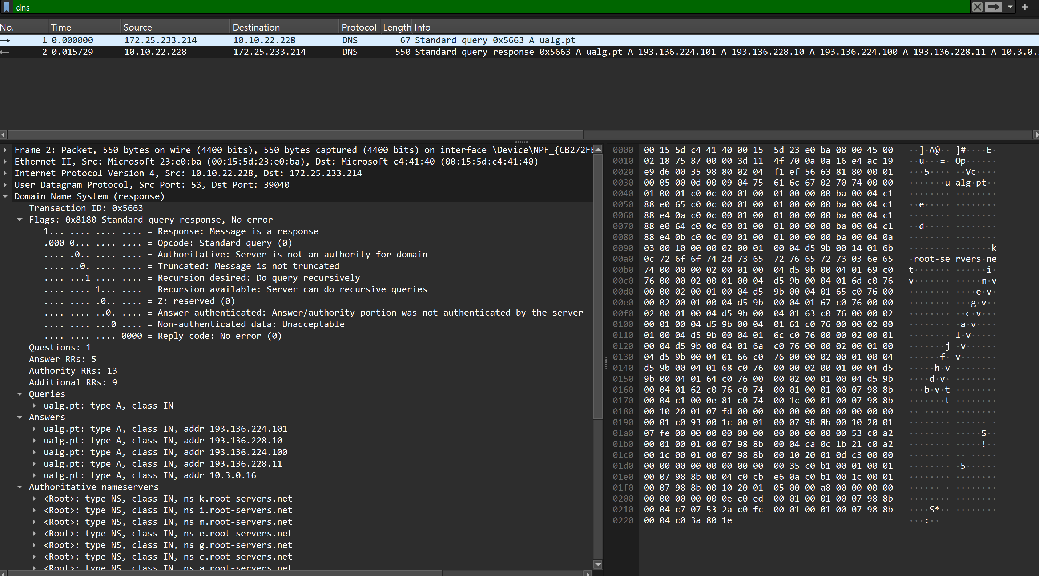
Resposta

